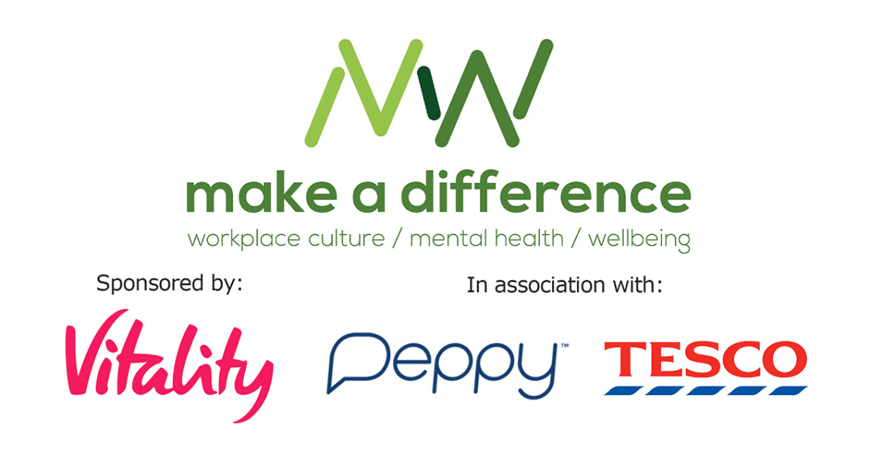
“Understanding the Menopause and How Employers Can Help” webinar: golden nugget tips from the speakers

Kathy Abernethy, Director of Menopause Services, Peppy and immediate past Chair of the British Menopause Society:

We’ve come a long way, but menopause is still a tricky topic for many people to discuss, particularly at work. You can help by investing in the right workplace initiatives. Henpicked: Menopause in the Workplace helps companies break down the stigma with their training, policy and communications expertise. Peppy offers a safe space for employees to connect with menopause practitioners over chat and virtual consultations, anonymously on a secure mobile app.

Dr Anushka Patchava, Deputy Chief Medical Officer, Vitality:

Be the change you want to see. I’d encourage all our audience to speak up, to be curious and seek information, and ask questions to better understand menopause and it’s impact. Through this we can create more psychologically safe spaces for others to speak up and normalise the conversation and the condition.

Pippa Andrews, Director of Corporate Business, Vitality Health:

Increase the visibility of menopause and its possible impact on everyone. Start the momentum, share with your employees that you recognise menopause as a distinct topic and perhaps start to signpost that as a business – you want to support your employees. If possible, have your senior people write about it, talk about it and open the conversation. Be open but sensitive, as many people really just don’t yet understand or appreciate the impact menopause can have.

Look for expert menopause support to support your people or HR function in this dialogue. Our menopause partner Peppy is included within our PMI health plans for individuals and organisations for exactly that reason.

Fiona Mackay, People Partner, Tesco:

Listening is your greatest super power, be curious and patient. If you can make something just a little better for one person today, it’s more than you achieved yesterday.

