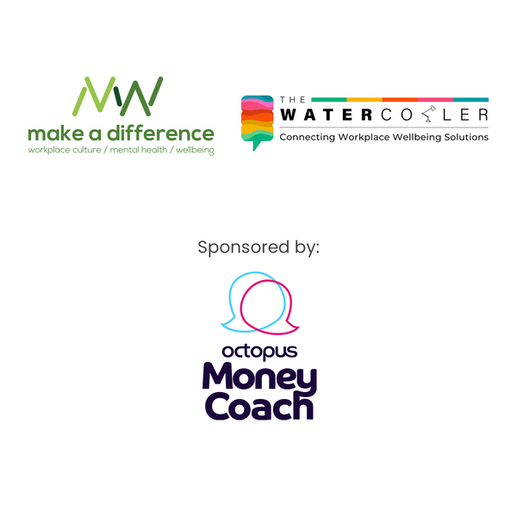
Links, tips and resources shared during our
19th January 2023 webinar
“Engaging a ‘financially fatigued’ workforce to keep their
financial wellbeing front of mind”
Tips around engaging your people with your financial wellbeing support
This may be interesting to check out - tips on mistakes to avoid: https://makeadifference.media/newsletter/13-mistakes-to-avoid-when-opening-up-the-conversation-about-money-with-employees/
We run cup & cake days for all our staff to drop in, we have our MHFAiders present and make lots of flyers available and then also encourage our teams to take advantage of our cash plan medical cover, pension benefits etc
It's important to take a holistic approach, rather than just finance or just MH
We do a Benefits Presentation to all new starters each month and this is open to all current staff as well, to keep them reminded about what we offer and how to access these
The HM Gov Help to Save scheme? - There is a bonus from the Government of up to 50% of the individual's investment amount
We have recently run a week of webinars on different the benefits we have in place, this included financial wellbeing. Feedback was very positive.
I didn't know about the Help to Save Scheme either, I’ll have to look into it. We do offer access to ISA's but not via HM Gov
One thing our younger workforce seems to have engaged with is a TechScheme
@Jamie - have you, Serco, or anyone attending considered using the NDI metric adopted by the PayPal CEO - it seems to really chime with your 'I wish my manager knew'
We generally do a blanket salary increase but did pay a cost-of-living payment which was not offered over SMT Level
We have done an interim advance salary payment bringing forward part of the award for April 2024. We did scale this for the early payment, but the full award will align.
Any suggestions on how to identify what it is that our people might need help with, we have the financial wellbeing and MHFA approach, with EAP etc, but how do you really identify that's what our people need?
Thank yous
Thanks so much for a great session! Thanks to all - lots to think on, lots of great ideas
Brilliant webinar, thank you so much! Really useful – thank you
Thank you very much Thank you, great session

