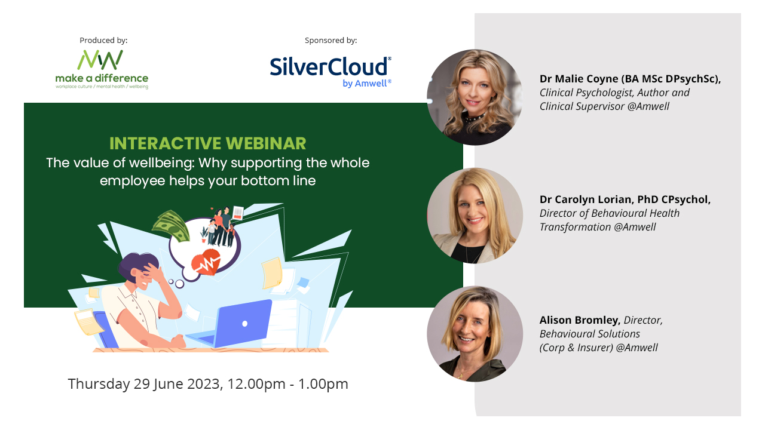
Supporting Parents & Caregiver Mental Health in the Workplace webinar
Links & tips shared in the chat
Links:
Useful resources from our sponsor SilverCloud by Amwell:
Extending the circle: Delivering a “whole person” workplace wellness strategy whitepaper: https://www.silvercloudhealth.com/uk/landing-page/health-plans-playbook

UK research: https://www.silvercloudhealth.com/uk/landing-page/workplace-wellbeing-whitepaper

Irish research:
https://www.silvercloudhealth.com/en-ie/whitepaper/meeting-the-challenge_workplace-mental-health-in-ireland-today
SilverCloud by Amwell’s previous webinar recording on ‘Supporting Parents & Caregiver Mental Health in the Workplace’
Recent research from Morgan Stanley about how companies can support working parents in a children’s mental health crisis:
https://www.morganstanley.com/articles/childrens-mental-health-effect-on-parents
Coverage on Make A Difference Media recently about employees struggling to return to work after parental leave/ the caring load:
‘I’ve struggled with confidence returning to work after mat leave… and working from home wasn’t necessarily best for my wellbeing’
‘What I wish for other working mums, this Christmas and in 2023’
‘We need an honest conversation about female burnout: it starts here’
Audience comments
Subject: how difficult parenting is in modern society
Yes I think that it is harder

We no longer have our village!

More pressures on children for parents to navigate including social media etc

I think children/teenagers have a harder time which makes parenting harder

Absolutely we dont have our village!

Yes it’s harder and think social media has not helped

I think parenting is different now, the world has changed so much and as such our role as parents has changed too

I'm now a nan and see how difficult it is for my children parenting their children in a world of social media and technology.

Yes I have a 32 year old son and now raise my grand-daughters who are 5 and 7 and its completely different and far more difficult due to external influences

I have a child with complex needs and work time

I am a nan who has her daughter and her son whio live with me who is visually impaired and has other issues really hard sometimes

I had to go part-time to look after my child as costs are eye watering expensive
Subject: today’s parents have the stress of childcare as well as caring for their own parents
I have recently become secondary carer to my aging mum who is a widow and suffers from short term memory loss, lack of confidence travelling on her own on public transport. Had not realised how much mental energy I need to look after her until now!
Maybe it can also depend on whether your employer is a parent…..
Well said - caring for ageing parents with illness can actually be more stressful - I have found that they are more demanding.

I’m also torn between a demanding mother and my child with anxiety, a brother who had a stroke and a estranged sister
Subject: how a loved one having mental health struggles impacts an entire family
I have not children but I support my husband with his anxiety which effects mine

Supporting partners is really difficult when it effects your own
Subject: what audience members are already doing/suggestions
We have an excellent 'Working families' employee network at work and are just about to set up an 'Eldercare' network as we know there is increasing demand for this support.

We have just set up a Parent and Caregiver affinity group

We have wellbeing champions and Mental Health First Aiders

We have a Parents and Carers group - it is employee led and is a trusted, supportive community. We also have a Family and Dependent Care Leave Policy, allowing people to take up to 5 days off per year for family emergencies.

We have a Parents & Carers network and we've found there is a huge need to support parents & carers in the workplace. To echo what has been said, we are finding there is an increasing need to support those who are caring for elderly family members with health conditions such as dementia

we have a parents network and carers network. We have a pledge that support them and it's contained in a document with useful links for support, hints and tips to help conversations with managers, how to support one another, entitlements for paid time off and also support in managing your career.

as well as supporting parents with children with neurodiversity and anxiety
I am the Wellbeing Lead at work and we really forward thinking. We have a wellbeing room, self care treatments, time off for wellbeing being weekly and fully flexible working. I have recently taken this role and am looking at additional support

Off the back of an internal mental health event we ran, some of our working parents who have a Autistic children, decided to set up a group called 'Autism Awesomes' - a closed/private group to help support each other.

ella my son is autistic so would be interested to hear about that

To add on to what my team member Ella has already said - our groups also hold events and learning opportunities either with our internal experts or with external partners so even with colleagues who, as you say Sam, are not ready to join a group - there is still learning and support available for them

We try and use the positive communication, and often it works but we struggle with the schools as they don't often take this onboard.

We try and use the positive communication, and often it works but we struggle with the schools as they don't often take this onboard.

To add on to what my team member Ella has already said - our groups also hold events and learning opportunities either with our internal experts or with external partners so even with colleagues who, as you say Sam, are not ready to join a group - there is still learning and support available for them
Subject: struggle to return to work after parental leave
Agreed Alison - it's also important that parents returning to the workplace after a career break for parenting responsibilities know how to access the right support. The world of work has changed alot, in the last 3 years

That's so true Alison! I remember having to go back on the road after my first daughter was born but I had also had post partum mental health issues....and only had 6 months leave and I was back on the wagon!
Subject: what parenting support is helpful
Spot on! Print outs are very helpful. I printed out some resources for a family member recently (it felt very old fashioned!) when they needed support and left it with them to quietly read through. This was so much more impactful than sending a link to read online, as we had a really good discussion afterwards.

Sam, we attended a parenting workshop recently, and they shared how you can't tell your children not to swim when there is a swimming pool, you can get in and swim with them...I loved that.
Other:
Many years ago I had to give up my studies when Mum got divorced so she could continue working and I took a night job and took on the parent responsibilities during the day with very broken sleep. Flexible working wasn't a thing 15 years ago but, if we did have that, the story might have been different.

­­­Is it possible to please get a copy of this slide deck after the presentation? My email address is leora.mofsowitz@compasspathways.com

Do your forums have influence in policy @ella

Yes they do have influence on policy where it is possible

That's great, Ella!

I am also a wellbeing lead for my organisation and a parent. Also happy to contribute.

Hi Laura - can you send me your email address too.
Could I have emails address from you both please as we do a lot of what has been said but like the sound of other things that are being said

Hi Julie and Jo, I would also be happy to connect, please feel free to reach out through LinkedIn @Terry Mattheoyianni - Thanks

laura.allwood@a2dominion.co.uk - I am also on LinkedIn.
e and Jo, I would also be happy to connect, please feel free to reach out through LinkedIn @Terry Mattheoyianni - Thanks

laura.allwood@a2dominion.co.uk - I am also on LinkedIn.

I think there are two Jo Briggs on this call today!

I'm an Employee Experience Lead and would love to connect with anyone on here too - I'm on LinkedIn

My work email is Julie.burnett@advocacyfocus.org.uk
I also have a business email which is carebeyondcompliance@gmail.com I am also on linked in

That sounds brilliant Ella are you also on Linkedin
Thank yous:
This has given me a really great takeaway
Thank you

Unfortunately I have to leave the webinar and look forward to receive slides and recording later. Thank you for the informative session :0)

Would like more info on this please as my grandson has this and autism as well

Thank you very much. It was very good presentation. I appreciate your time, but need to head off. Take care.

Thanks

Thank you for a very interesting session

I have to leave now but very interesting. Thanks.

Thank you all for your time

Thank you loved this

Thank you for a great presentation

Thanks very interesting

All very interesting, thanks so much.

Thank you everyone!

Thank you

Thanks for today!

Thank you for an interesting session, lots to think about

Great session - lots of information, great ideas, Thank you all

Thanks all

Thanks
Questions from the audience:
How do we access these programmes?

what is the cost of these programmes?

Will all of the information being discussed be sent out to us to see what we will need and costs.

Do you have more information on that and how to access?

Has anyone been able to set up support/network groups in environments where colleagues do not have access to their company networks. e.g. manufacturing/retail environments?

If your employer doesn't sign up is there packages out there similar for individuals?
Answering these questions:
Our panellist Alison Bromley, Area Sales Director at SilverCloud by Amwell, is happy to organise 15 minute one-to-one conversations to anser these questions, or with anyone who would like to know more following this webinar.

She can be contacted on:

alison.bromley@silvercloudhealth.com

