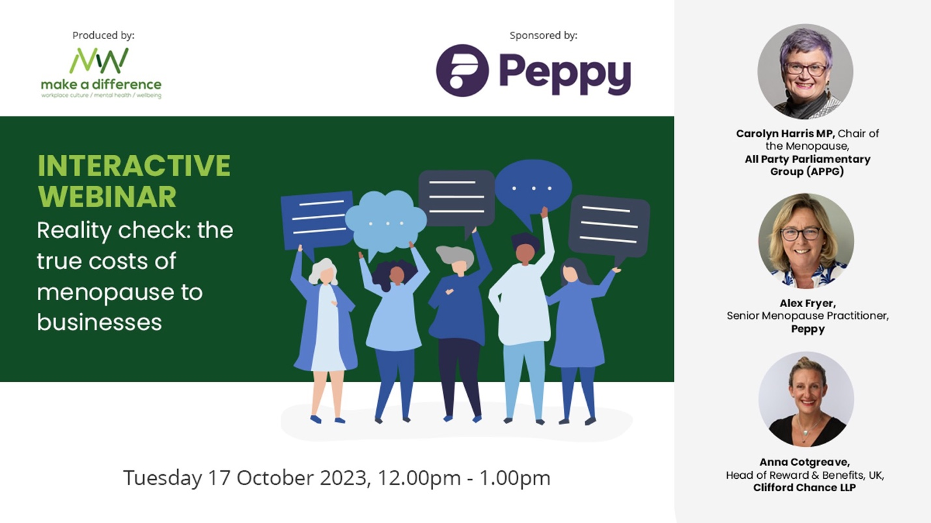
The True Costs of Menopause to Business Webinar
Links & tips shared in the chat
Links:
The Co-op have made their menopause publicly available for other employers to use as a guide: https://colleagues.coop.co.uk/co-op-menopause-support-policy
The source of the 1 in 10 statistic in Alex’s presentation comes from The Fawcett Society: https://www.fawcettsociety.org.uk/menopauseandtheworkplace
Carolyn Harris MP described the BSI’s free download guide on Menstruation, Menstrual Health and Menopause in the workplace as “excellent” - it can be found here
Make A Difference Media article with Natalie Beresford, Former Detective Inspector at Thames Valley Police, saying “The menopause destroyed my life, personally and professionally” can be found here.
We have also asked Anna Cotgreave from Clifford Chance if she is happy to share the guidelines which she mentions. Please contact claire@makeadifference.events if you would like to receive these.
You might also find the free resources on Peppy’s World Menopause Day hub useful.
Henpicked’s free resources were also mentioned.
Audience current challenges:
I am looking to update our menopause policy, we offer support through a private health scheme that every EE is enrolled into
Hi everyone, thanks for having me. I work in HR in Social Housing. We are providing support as an organisation - we have implemented a policy, have done training and awareness sessions and set up a menopause support group that anyone can attend. We also have a health scheme/EAP. The challenge seems to be for individuals managing their symptoms and getting the right medical support and treatment.
We have rather a dated policy that I feel needs complete rewriting so I am hoping to get some ideas. My personal experience was medically induced so I am hoping to get a broader idea of what support people would benefit from most
We do not have a policy currently in place within the Council but I guess having a group this could be something moving forward
Hi all I work in HR within the Facilities Management Industry. We have only pulled together a Menopause Policy so we are at the beginning of our journey to implement support. Some great suggestions coming through :-)
We have tried with our insurer but they have refused and class menopause as 'chronic' so it is excluded. It's frustrating. I'm sure once our contract comes up for renewal it can be a point of discussion if we re-tender. I would be interested to hear who Clifford Chance's insurer is and what is covered in the PMI policy! understand if that cannot be shared in this forum though.
Working for a Local Authority we are constantly told there is no budget for our MenoPALS support group so we pay for the tea, coffee, products etc out of our own pockets. It's so frustrating but because we are so passionate and so many of our workforce need us we keep going! We have recently been donated some little funding from our union!
As menopause is different for everyone, I prefer guidelines rather than policy because policy can seem like a tick box exercise with symptoms and circumstances shoehorned in.
Menopause policy comments
guidance is good idea - is there a sample/example of what this could look like?
Anna - would you consider sharing your Menopause guidance document/pack please?
would be really great to get some sample on guidelines docs
Echo that on guidance sample :)
I think having a policy helps support the individual going through it with re: physical and psychological symptoms and how they impact in the workplace, also support managers and help educate/raise awareness - taken more seriously
We also have a Menopause guide in place as opposed to policy (NHS Trust). It has as section for those going through the menopause, guidance for supporting your colleagues who are going through the menopause and guidance for line mangers supporting staff goings through the menopause.
Private Medical Insurance is an interesting one. My guess is that Clifford Chance has a Healthcare Trust which means they can self fund what they want. If I'm wrong then it's good to hear that their insurer is listening.
My colleague and I are on this webinar - we are not in HR but we have through lack of support in the workplace set up MenoPALS which now has 70 women in the group. We do this outside of our day job and have changed work practices and process. We have a menopause risk assessment, it's on our sickness policy, we have a menopause policy, training for Managers etc. HR and tapping into it which is brilliant. We continue to beat the drum. Our organisation has also now signed up to the MenoPause workplace pledge. We have also done presentations to other organisations on what we have done and how we have done it. Thank you for this today, we will have the recording and send to HR! We do not have a policy currently in place within the Council but I guess having a group this could be something moving forward.
What audience is already doing
We are just setting up a Menopause Support Group, which I have only just recently attended myself but already we have interest and are holding two events tomorrow for the Menopause Day to encourage more interest within this area for council staff.
Many people who've attended our menopause support group have talked about how long it's taken to identify the cause of their symptoms (many incorrectly diagnosed anti-depressants) - awareness and open conversations are so important. We also ran awareness sessions for men which was really well attended :)
Care packages - we have this in my work place (Am part of a MP Group in one of our TMRG Teams
Menopause and the law
I agree re: not making it a protected characteristic.
I did feel that there was a lot of 'hang up' in the media on the protected characteristic point which overshadowed other more important points. I agree with Carolyn...it is not necessary if you have the right support in place.
would be really great to get some sample on guidelines docs
Men and the menopause:
Hopefully there are men attending this and finding it useful?
Yes and Yes.
Yes and Yes
Male allyship is important in the workplace
Agree that it's so important to bring men into this conversation. Anna will be talking a bit about this too.
When bringing men in to the conversation, does the issue of the andropause ever come up?
Comments on personal experiences
My GP said that it wasn't the menopause / perimenopause if I wasn't getting hot flushes...
my personal experience of my GP is that it was depression and I was put on anti depressants.
I was offered anti depressants which I refused. It has taken me two years to find the right support and treatment through my GP
Nurses retired at 55 from NHS …. Broken
I was 43 when I started with symptoms. Dr would not help as I was under 45 and the one blood test they gave me was borderline. I changed GP and they couldn't understand what I had been told as symptoms may be cyclical and the week after a blood test result would likely be different.
I would love to find the menopause support locally but have just had to do my own research and fighting my way through the fog of it all
I feel my GP surgery doesn't have the specialist knowledge required to offer support, guidance and advice. I enquired about HRT and asked for further information and clarity on the benefits and differences but didn't feel that was fully explained, I am now exploring private menopause clinic support options
I can't take HRT due to having had breast cancer and was only offered anti-depressants by my GP, so I am trying hypnotherapy to help with the anxiety and feelings of inadequacy and paranoia. It's early days but it does help me relax. It is expensive though, so don't know how long I can keep paying for it.
it's very sad. Working full time and trying to look after yourself is really difficult.
My GP said I wasn't far enough through the menopause to get HRT. I've been having perimenopause symptoms for around 10 years and I'm not 52, it's so frustrating that they won't prescribe HRT.
My GP was amazing. Went there feeling low - had a couple of things in my life that weren't great and it felt I had a tangible reason...but I felt as if nothing could give me joy (I'm a really upbeat person). She was the one who told me that it was all connected. She helped a lot. I'm so lucky to have her.
Well said Carolyn. I think that awareness is important for all ages. My daughter is 25 and a manager who manages a women who is going through similar symptoms to me and she only knows how to support her because I am also going through this. If it was mentioned as a natural occurrence from a young age to both men and women, more people would know how to support without making it a big thing.
Other reaction to content being shared
Ethnicity numbers are a shock for me …
I’m so happy to hear that Carolyn found out the causes of her symptoms, but equally so angry that it’s taken so long to drive knowledge about and investment into women’s health issues. We must do better.
Carolyn is brilliant....
Love Carolyn!
It's important to think about 'workspaces' not just workplaces.
I’m a yoga teacher and have recently done Petra Coveney’s Menopause Yoga Teacher Training - through this I’ve discovered so many things I can do about my peri menopausal symptoms; HRT, exercise, diet etc etc. There are now a whole tribe of disciples out there who are passionate about helping other women and trying to make their workshops and classes as affordable as possible. A lot of them are virtual too, so accessible from wherever you are!
Yes what wonderful speakers!
Employers mentioned
Vodaphone has a good policy. The Co-op is also good.
Questions about Peppy:
Is Peppy available to employers outside the UK/Europe?
Thank yous
Thanks for arranging this.
Thanks all - really interesting discussion

I’ve found the discussion really interesting, thank you! Would welcome any resources that are shared.

Thanks for the insights

Loved this session, thank you so much.

Carolyn is fab

Thank you

Great session, thank you so much

You all 4 are great, thanks so much!

Thank you fab session

Thanks all - great session!

Thanks everyone

Thank you so much

Thank you, great session.

Fabulous session thank you

Brilliant session, Carolyn you are our hero!

thank you all so much!!!

